Project Description :

I have created the webpage "SBI". I have created doing this by creating four(4) .html files.

So, The main agenda for this web page is that, we can find the details of employees working in certain branch.

We can also find the detailed information about the bank.

Requirements : HTML, CSS, Boot Strap, Sass

The above mentioned requirements are needed to develop a webpage.

It helps in creating the WEBPAGE more effectively.

In-Detail about project :

1. I have created the HOME PAGE of SBI.

2. The first page includes the links of employees working in a bank

3. It also includes the detail information  about bank that is information about the bank, regarding exams, contact information.

4.I have included some images related to the bank

5.I have differentiated the page with different font-style and color

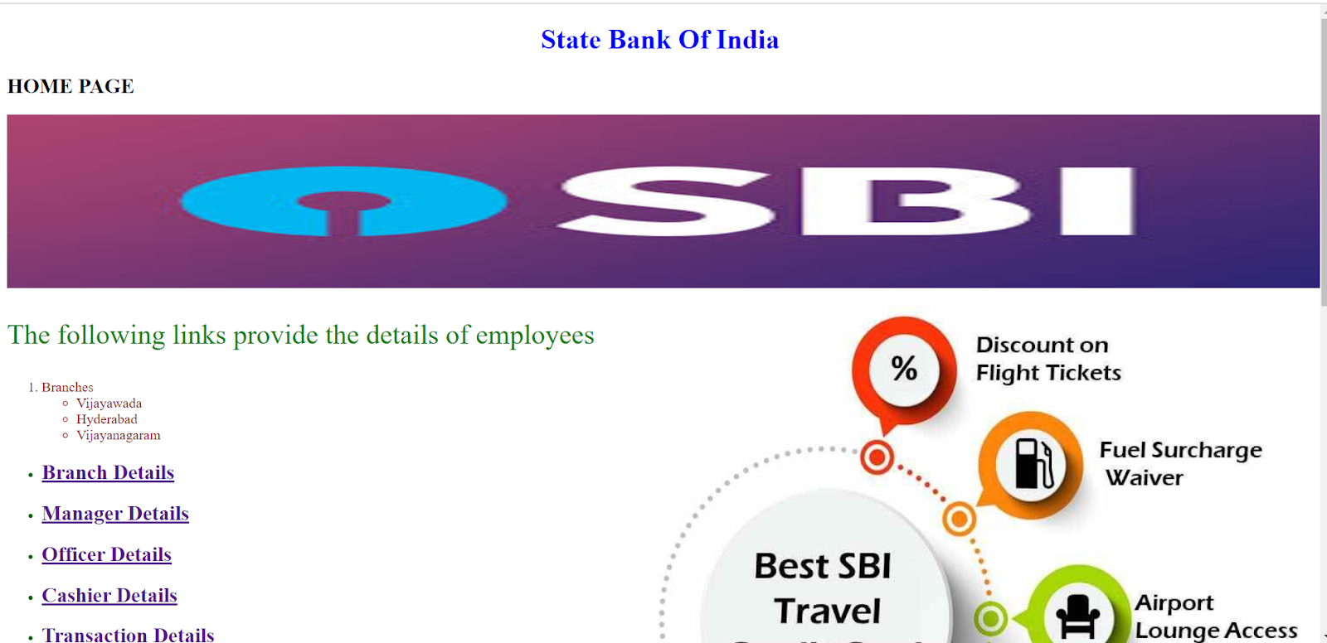

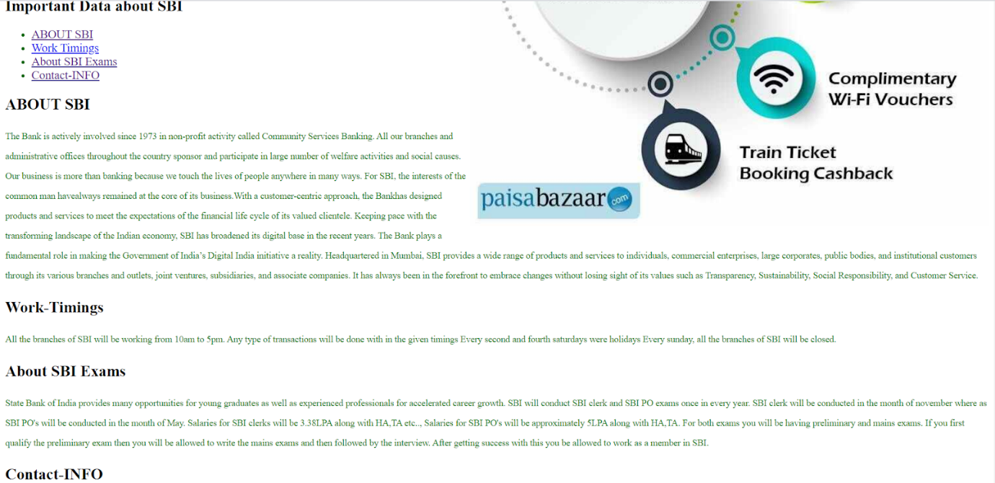

* This is how my web page looks like

-> I have mentioned that there are three branches in my home page

-> So, it gives the information of all these mentioned branches

-> If i click “Branch details” then the details and the information about branch will be given in that page

* My branch page looks like:

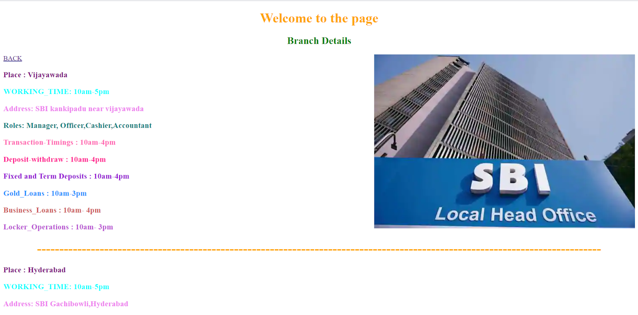

-> Similar to the branch page I have created a webpage of “Manager”, ”Officer”, ”Cashier”, ”Transaction”

-> Transaction details includes the details of person, place and age

-> It doesn’t include the personal details that will be very confidential.

* MANAGER DETAILS page

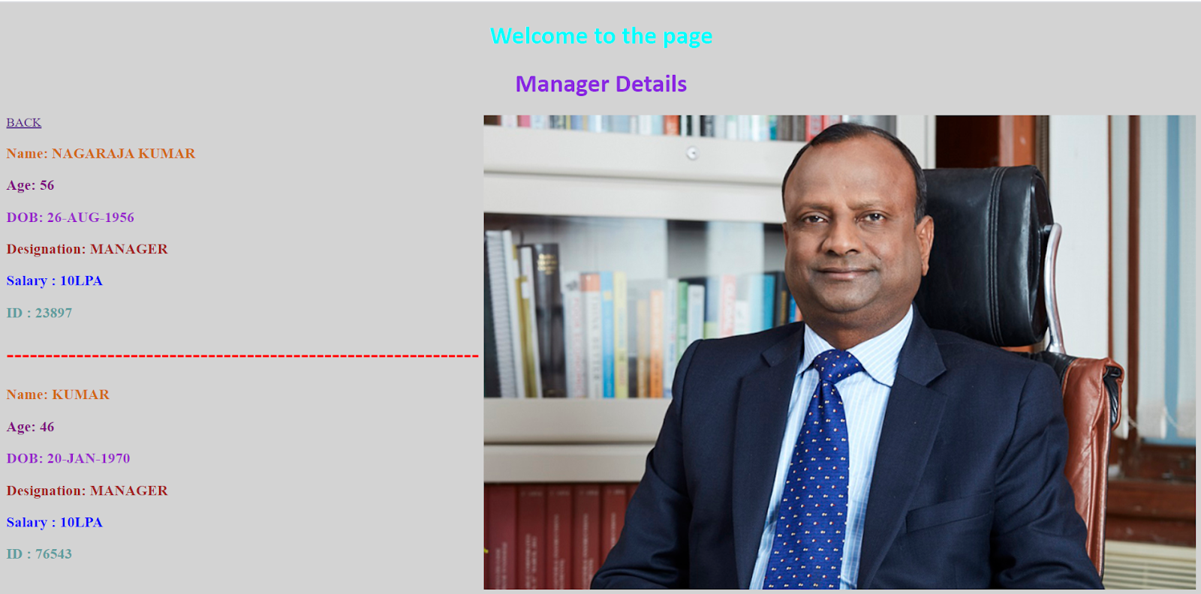

* OFFICER DETAILS page

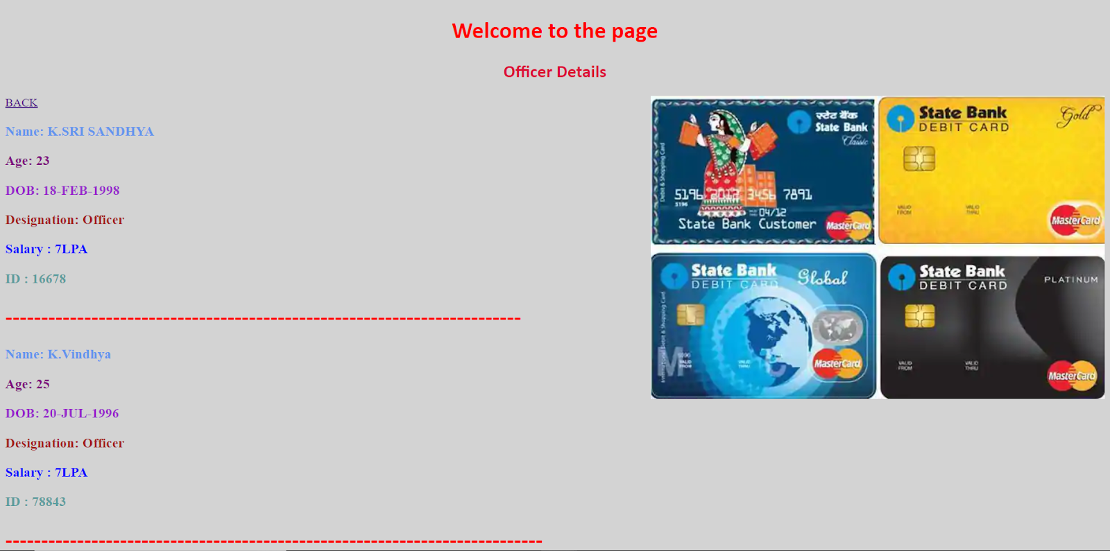

* CASHIER DETAILS page

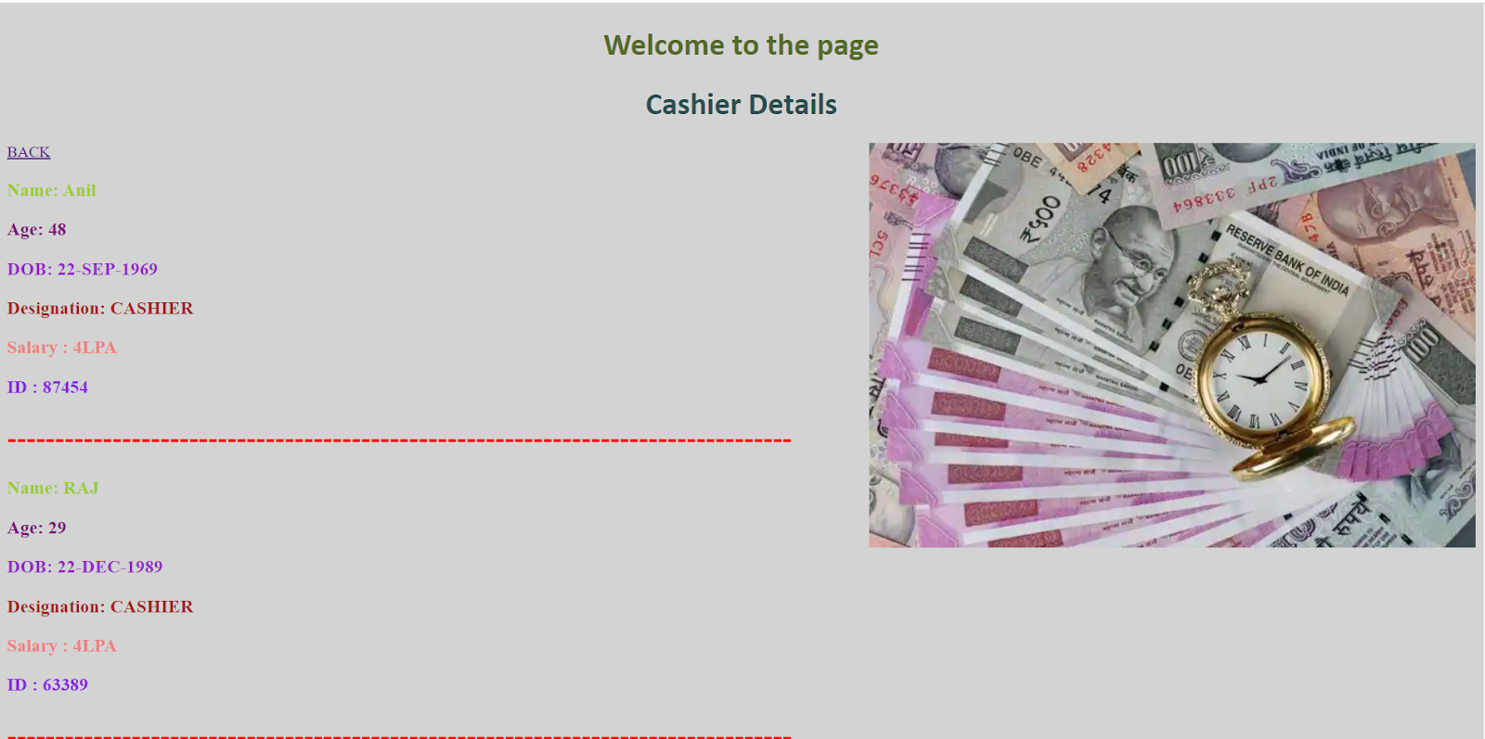

* TRANSACTION DETAILS page

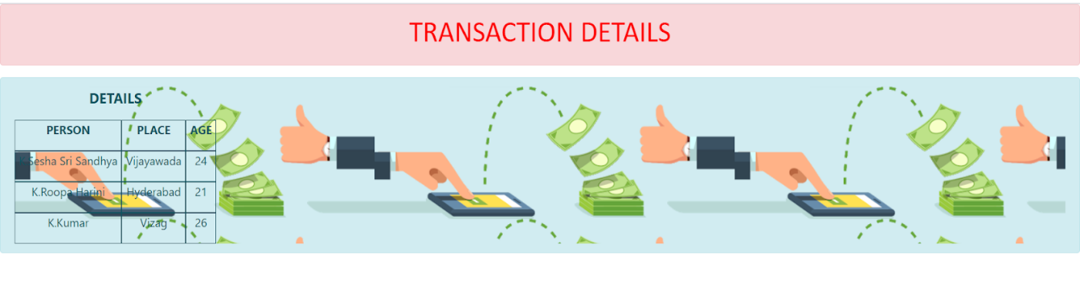

We have used CSS(Cascading Style Sheets) for designing my webpage)

CSS includes - Font-style, font- color, width, height, images, size, padding….  
HTML includes - Title, body-all the content, paragraph, **ordered and unordered lists, image, tables, forms, div**

**Scss - instead of writing in different ways of styles in CSS we just put it in one single way so that it can apply to all the pages**